ARBEITSPLAN-2

|  |  |
| --- | --- |
| Klassen: | **F3** |
| Fach: | **Englisch** |

|  |  |
| --- | --- |
| **Themen im Unterricht** | **Arbeitsmaterial** |
| UNIT 13: DILEMMAS | STB/pages: 134:1+2; 135:3 |
| WB/page:99/100:1+2 |
| WB/page: 100:4+5+6 |
| IF-SENTENCES (2nd Conditional) | STB/page:137 |

|  |  |
| --- | --- |
| **HAUSAUFGABENTAGE:** | |
| **Gruppe A:** | **04.06.20– 10.06.20** |
| **Gruppe B:** | **11.06.20– 17.06.20** |

|  |  |
| --- | --- |
| Aufgabenstellung: WORDS AND PHRASES | |
| Write and study: MORE Words and Phrases, unit 13 | WB/page 105 |

|  |  |
| --- | --- |
| Aufgabenstellung: GRAMMAR | Arbeitsmaterial |
| exercises: page:101: 7-10 | WB |
| exercises: page: 102: 11-13 | WB |

|  |  |
| --- | --- |
| Aufgabenstellung: VOCABULARY | Arbeitsmaterial |
| exercises: page: 103: 14-16 | WB |

|  |  |
| --- | --- |
| Aufgabenstellung: READING | Arbeitsmaterial |
| Read the play. Then tick T(True) or F(False) | worksheet: schedule: page 2 |

|  |  |
| --- | --- |
| Aufgabenstellung: REVISION | Arbeitsmaterial |
| modal verbs: *may/can* | worksheet: schedule: page 3 |

|  |
| --- |
| Aufgabenstellung: CHECK YOUR WORK |
| * Take a colour and check the workbook exercises (pages: 101 – 103) with the solutions at the end of the book. * Take a colour and check the exercises on page 2 and 3 (schedule) – you find the solutions on page 4 of the schedule. |

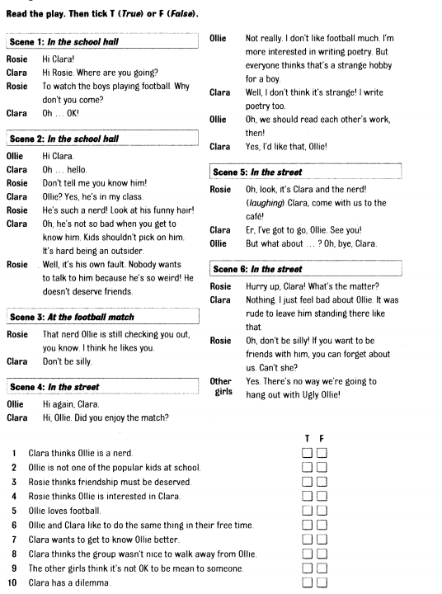

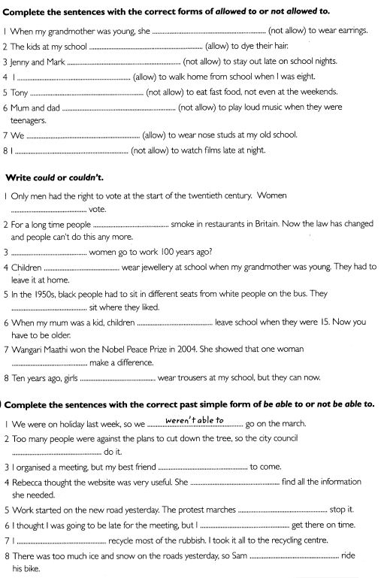

|  |  |
| --- | --- |
| HAUSAUFGABENPLAN (2): solutions | |
| READING | schedule: page:2 |
| 1F; 2T; 3T; 4T; 5F; 6T; 7T; 8T; 9F; 10T; |
| MODAL VERBS | schedule: page:3 |
| exercise 1 | 1-wasn`t allowed;2-are allowed; 3-aren`t allowed;4-was allowed; 5-isn`t allowed; 6-weren`t allowed; 7-were allowed; 8-`m/am not allowed; |
| exercise 2 | 1-couldn`t; 2-could; 3-Could; 4-couldn`t; 5-couldn`t; 6-could; 7-could; 8-couldn`t; |
| exercise3 | 1-weren`t able to;2-wasn`t able to; 3-wasn`t able to; 4- was able to; 5-weren`t able to;6-was able to; 7-was able to; 8-wasn`t able to; |