Arbeitsplan NMS Kematen
Vor-/Nachname: ______________________ Klasse: ___
(Schüler/in)
Fach: Englisch
Schulwoche: 36 | 11.05. – 17.05.2020

Aufgabenstellung: | Arbeitsmaterial | Erledigt am:
Check and correct:  last week`s work. | *Lösungen: Arbeitsplan:  Seiten: 3 – 4
Copy (schreibe) and study (lerne)  die word file words, words and phrases der Unit 11. | Vokabelheft/Workbook: page:99
Do the exercises:  Workbook p.92/1 and Workbook p.93/4 into your Workbook. | Workbook: page:92;  Workbook: page:94
Reading comprehension:  Read the story “The horse can count”- Student`s book p.72/6 and do number 7. | Student`s book: page: 72
Grammar: Irregular plural nouns Workbook p.88/13  Question words: Workbook p.88/4  Vocabulary: Workbook p.89/17 | Workbook: page:88  Workbook: page:89
Writing:  Write the questions for the answer into your Workbook: Workbook p.88/15  Write sentences about the pets into your Workbook: Workbook p.89/18 | Workbook: page:88  Workbook: page:89

*Es ist nicht notwendig, die Lösungen auszudrucken!

Freiwillig für Fleißige …
Aufgabenstellung: | Arbeitsmaterial | Erledigt am:
Do the crosswords. | Arbeitsplan: Seite 2

Überprüft und besprochen mit einem Erziehungsberechtigten: Kontrollieren Sie bitte nur auf Vollständigkeit und nicht auf Richtigkeit!!!
Datum: __________________
Unterschrift des Erziehungsberechtigten: _______________________________________________

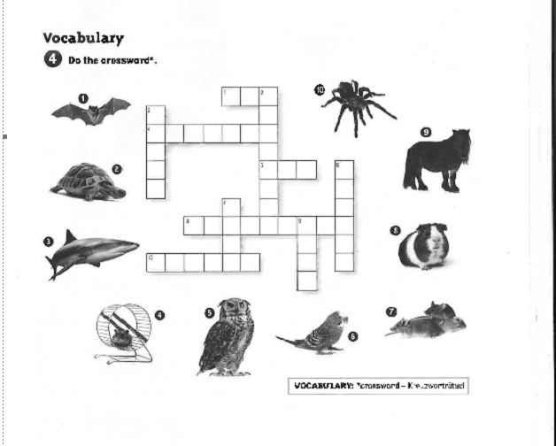

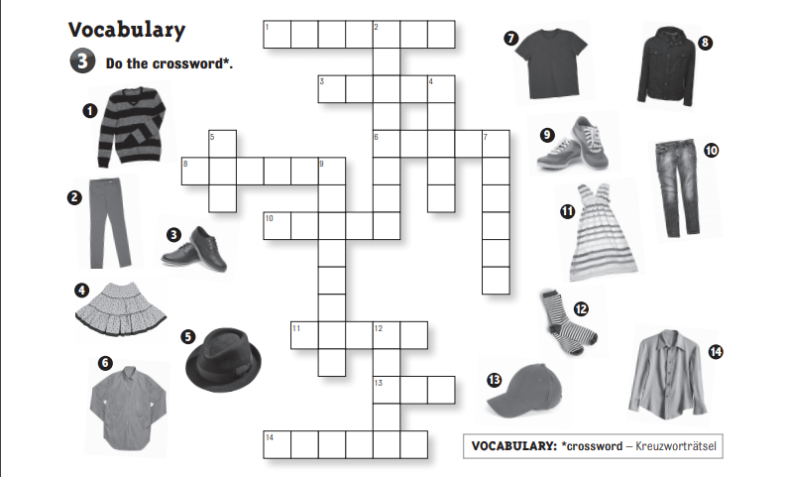

SOLUTIONS:
schedule:page 2: Find the words of the animals and write them down.
esiotrot |  | tortoise | tab |  | bat
low |  | owl | krahs |  | shark
gip aeniug |  | guinea pig | esroh |  | horse
tibbar |  | rabbit | ecim |  | mice
esuom |  | mouse | redips |  | spider
hsif |  | fish | retsmah |  | hamster
eigdub |  | budgie | god |  | dog
yeknom |  | monkey | tac |  | cat
schedule: page2: Fill in the correct English word.
1 | The ending of the book is very strange. |  |  | Ende
2 | Best wishes to your mum and dad,Peter. |  |  | herzliche Grüße
3 | He always begins his emails with “Hi!” |  |  | anfangen
4 | Have you got an unusual pet? |  |  | ungewöhnlich
5 | I have a mouse and a dog, but my friend has six mice. |  |  | Maus - Mäuse
6 | He feeds his hamster once a day. |  |  | einmal
7 | Crocodiles are dangerous animals. |  |  | gefährlich
8 | My dad always reads the newspaper. |  |  | Zeitung
9 | Thank you for the letter. |  |  | Brief
10 | We don`t like him very much. |  |  | viel, sehr
schedule: page 3: FILL IN: my, your, his, her, its, our, their:
Simon says:
Bend your knees! Raise your arm! Stamp your feet! Clap your hands!
Put your left foot on the chair! Shake your hair! Shake your head!
Look at Tom!
He can stamp his head. He can bend his knees. He can stamp his feet.
He can raise his arms. He can put his right foot on the table. He can stand on his head.
Look at Sandra!
She cannot bend her knees. She cannot raise her left arm. She cannot shake her leg. She cannot touch her nose, her ears, her mouth and her hair.
Look at Bill and Betty!
They must touch their noses, their eyes, their knees.
They must shake their heads, their hair, their arms.
They must stamp their feet.
schedule: page 3: COMPLETE THE SENTENCES WITH my, his, her, our, their
Hi, my name is Melanie and I`m twelve years old.
These are my parents, Carol and Paul.
My mother has got dark brown hair. Her eyes are green.
My father gas got brown hair and his eyes are brown, too.
Next to my parents you can see my brother Mike.
He`s the tallest in my (our) family.
My favourite sport is basketball and he`s very good at it.
Our house is really big and we also have a big garden for our dogs.
Tim and Tony like going for long walks* and their favourite food is fish.
I love playing with them.
It`s never boring* with my parents, my brother and my dogs.

schedule: page 4: |  | T | F
1 | Frieda`s pet is a bat. | x
2 | Her pet`s name is Burgi. |  | x
3 | Frieda keeps the bat in a cage in her room. |  | x
4 | The bat can dance. |  | x
5 | The bat is very very clever. | x
6 | The bat comes to Frieda`s room in the evening. | x
7 | She sleeps in Frieda`s room. |  | x
8 | Frieda`s bat eats ice cream. |  | x

schedule: page 4:
1 | What animal is Fluffy? | Fluffy is a big dog.
2 | Where does it live? | He lives in a small house in a garden.
3 | Who are its owners? | Anny and Susie are his owners.
4 | How old are they? | Anny is twelve, Susie is five.
5 | Is Anny nice? | Yes, she is nice.
6 | What does Susie think? | She thinks that Fluffy is a pony.

schedule:page 5
1 | Mr Black has got an unusual pet.
2 | He has got a dolphin.
3 | The dolphin`s name is Mr Bean.
4 | He keeps it in the swimming pool.
5 | The dolphin eats fish and beef.
6 | Mr Black feeds the dolphin four times a day.

schedule: page 5
COMPLETE THE SENTENCES WITH: How often / What / Where / What`s
Interviewer | Ms Grizzly, tell me about your unusual pet.
Mrs Grizzly | Sure, ask me a question.
Interviewer | What is it?
Mrs Grizzly | A tiger.
Interviewer | Wow. What`s its name?
Mrs Grizzly | Mr Strong.
Interviewer | Ha ha ha. How often do you feed him?
Mrs Grizzly | Once a day.
Interviewer | Where do you keep him?
Mrs Grizzly | In a small house in my garden.

