Arbeitsplan NMS Kematen
Vor-/Nachname: ______________________ Klasse: ___
(Schüler/in)
Fach: | ENGLISCH
Schulwoche: 35 | 04.05. – 08.05.2020

Aufgabenstellung: | Arbeitsmaterial (drücke STRG und klicke auf den Link) | Erledigt am:
Check and correct:  Last week`s work. | solutions: ¹schedule: page: 2
²REPETITION: words – unit 10  Write down the name of the animal.  Complete the sentences with the correct words. | schedule: page: 2  help:  workbook: page: 92  words-book
²REPETITION: unit 6:  ³possessive pronouns | schedule: page: 3  help: student`s book: page:42
READING AND ⁴COMPREHENSION | schedule: page: 4
READING AND WRITING | schedule: page: 5

¹ schedule = Arbeitsplan  ² repetition = Wiederholung | ³ possessive pronouns = besitzanzeigende Fürwörter  ⁴ comprehension = Verstehen

Freiwillig für Interessierte und Fleißige :HAVE FUN!
Halte die STRG-Taste gedrückt und klicke auf den Link:
https://learnenglishkids.britishcouncil.org/short-stories/the-animal-shelter
Zuerst machst du die Übung “PREPARATION“, dann hörst du dir die Geschichte an.
Anschließend gibt es ein Spiel dazu. Unter “DOCUMENTS“ hast du die Möglichkeit, die Geschichte auszudrucken und ein Arbeitsblatt mit Lösung wird angeboten-.

Überprüft und besprochen mit einem Erziehungsberechtigten: Kontrollieren Sie bitte nur auf Vollständigkeit und nicht auf Richtigkeit!!!
Datum: __________________
Unterschrift des Erziehungsberechtigten: _______________________________________________

SOLUTIONS: week 34
STB/page:63/4 | 1 – T, 2- F, 3- F,4 - 63 million, 5 – a bear;6 – a cheetah, 7- There are more dogs in the UK, about nine million. 8 – cheetah, tiger, leopard, … 9 – snake, scorpion, crocodile, leopard, cheetah ,…
STB/page:63/6 | 1-What is it? 2-What`s his name? 3-How often do you feed him?  4- What does he eat? 5- Where do you keep him?
WB/page:87/10 | 7,5, 4, 8, 3, 1, 2, 6
worksheet:page 4
exercise 1 | 1-g; 2-j; 3-h;4-k;5-d;6-l;7-a;8-e;9-i; 10-f;11-c;12-b;
exercise 2 | 1-What;2- How; 3-What;4-Where; 5-How often;6-Where;7-What;8-Who;
exercise 3 | A-How many; B-Where; C- What; D-How; E-What;F-Where;

Find the words of the animals and write them down.
esiotrot |  | tab
low |  | krahs
gip aeniug |  | esroh
tibbar |  | ecim
esuom |  | redips
hsif |  | retsmah
eigdub |  | god
yeknom |  | tac

Fill in the correct English word.
1 | The ______________ of the book is very strange. | Ende
2 | _______________________ to your mum and dad,Peter. | herzliche Grüße
3 | He always ______________ his emails with “Hi!” | anfangen
4 | Have you got an ________________ pet? | ungewöhnlich
5 | I have a _____________ and a dog, but my friend has six _____________. | Maus - Mäuse
6 | He feeds his hamster __________ a day. | einmal
7 | Crocodiles are ______________ animals. | gefährlich
8 | My dad always reads the ___________________. | Zeitung
9 | Thank you for the ________________. | Brief
10 | We don`t like him very _____________. | viel, sehr

Possessive Pronouns: my – your – his – her – its – our – your – their
Besitzanzeigende Fürwörter: mein- dein – sein – ihr – ihr/sein – unser – euer- ihr(e)

FILL IN: my, your, his, her, its, our, their:
Simon says:
Bend __________ knees! Raise __________ arm! Stamp _________ feet! Clap __________ hands!
Put __________ left foot on the chair! Shake __________ hair! Shake __________ head!
Look at Tom!
He can stamp ________ head. He can bend _______ knees. He can stamp _______ feet.
He can raise _______ arms. He can put _______ right foot on the table. He can stand on _______ head.
Look at Sandra!
She cannot bend _______ knees. She cannot raise ________ left arm. She cannot shake ________ leg. She cannot touch _______ nose, _______ ears, _______ mouth and _______ hair.
Look at Bill and Betty!
They must touch __________ noses, __________ eyes, __________ knees.
They must shake __________ heads, __________ hair, ___________ arms.
They must stamp __________ feet.

COMPLETE THE SENTENCES WITH my, his, her, our, their
Hi, _______ name is Melanie and I`m twelve years old.
These are _____ parents, Carol and Paul.
My mother has got dark brown hair. _____ eyes are green.
_____ father gas got brown hair and _____ eyes are brown, too.
Next to _____ parents you can see _____ brother Mike.
He`s the tallest in _____ family.
_____ favourite sport is basketball and he`s very good at it.
_____ house is really big and we also have a big garden for ______ dogs, Tim and Tony.
Tim and Tony like going for long walks* and _______ favourite food is fish.
I love playing with them. * Spaziergänge
It`s never boring* with _____ parents, _____ brother and _____ dogs. * langweilig

READING AND COMPREHENSION
A Read Emma`s text. Tick T (True) or F(False)
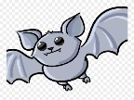
Hi, my name is Frieda. I`ve got an unusual pet.
It`s a bat. Its name is “Dark Beauty”. It lives in a big, old tree next to our house.
In the evening I open the window. Then DARK BEAUTY comes into my room .
DARK BEAUTY can speak and she tells me lots of stories. She is very clever.
At midnight DARK BEAUTY leaves. She flies around to find food. She likes insects.
So I don`t feed her. In the morning DARK BEAUTY flies back to her tree.
She sleeps in the tree during (während) the day.

 |  | T | F
1 | Frieda`s pet is a bat.
2 | Her pet`s name is Burgi.
3 | Frieda keeps the bat in a cage in her room.
4 | The bat can dance.
5 | The bat is very very clever.
6 | The bat comes to Frieda`s room in the evening.
7 | She sleeps in Frieda`s room.
8 | Frieda`s bat eats ice cream.

B Read the letter. Answer the questions in full sentences.
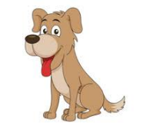
Dear Aunty Hannah,
I`ve got a problem. My name is Fluffy. I`m a dog and I´m very big. I live in a small house in a garden.
My owners are two girls, Anny and Susie. Anny is 11. She is very nice.
She plays with me, feeds me twice a day and cleans my box.
Susie is five years old – and that`s a big problem. Susie thinks I`m a pony.
She wants to ride on me all the time. She feeds me grass.
I don`t like grass, and I´m not a pony.
Sometimes Susie pulls my ears! What can I do?
Love,
Fluffy

1 | What animal is Fluffy?
2 | Where does it live?
3 | Who are its owners?
4 | How old are they?
5 | Is Anny nice?
6 | What does Susie think?

READING AND WRITING

WRITE THE WORDS IN THE CORRECT ORDER TO MAKE SENTENCES.
1 | unusual/ Mr Black/ got/ pet / has / an
2 | dolphin/ got / has / He / a
3 | dolphin`s / The / is/ Mr Bean/ name
4 | keeps / swimming pool / He / it / the / in
5 | dolphin / eats / The / fish / beef / and
6 | Mr Black / four times / feeds / a day/ dolphin / the

1
2
3
4
5
6

COMPLETE THE SENTENCES WITH: How often / What / Where / What`s
Interviewer | Ms Grizzly, tell me about your unusual pet.
Mrs Grizzly | Sure, ask me a question.
Interviewer | is it?
Mrs Grizzly | A tiger.
Interviewer | Wow. its name?
Mrs Grizzly | Mr Strong.
Interviewer | Ha ha ha. do you feed him?
Mrs Grizzly | Once a day.
Interviewer | do you keep him?
Mrs Grizzly | In a small house in my garden.

CHOOSE ONE OF THE ANIMALS AS YOUR PET. MAKE A DIALOGUE (see dialogue above).
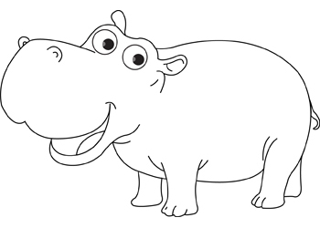hippo | Interviewer
 | You
 | Interviewer
 | You
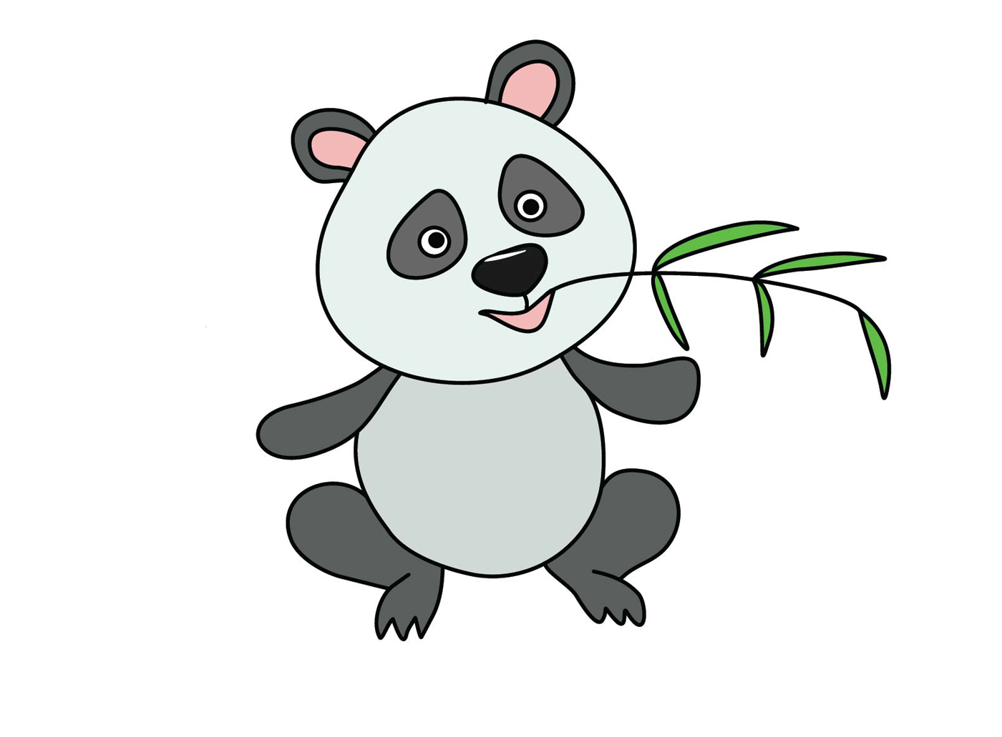panda | Interviewer
 | You
 | Interviewer
 | You
lion | Interviewer
 | You

